Prototype Design Pattern

Prototype Pattern says that **cloning of an existing object instead of creating new one and can also be customized as per the requirement**.

This pattern should be followed, if the cost of creating a new object is expensive and resource intensive.

Advantage of Prototype Pattern

The main advantages of prototype pattern are as follows:

* It reduces the need of sub-classing.
* It hides complexities of creating objects.
* The clients can get new objects without knowing which type of object it will be.
* It lets you add or remove objects at runtime.

Usage of Prototype Pattern

* When the classes are instantiated at runtime.
* When the cost of creating an object is expensive or complicated.
* When you want to keep the number of classes in an application minimum.
* When the client application needs to be unaware of object creation and representation.

UML for Prototype Pattern

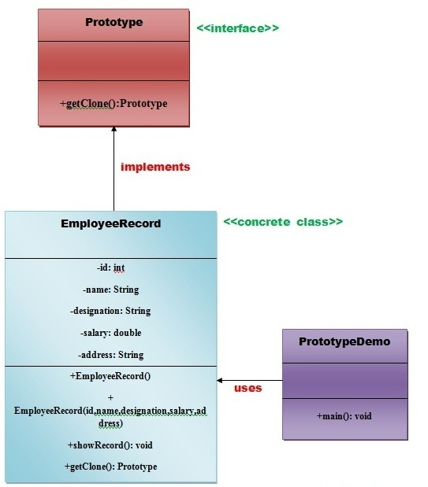

* We are going to create **an interface Prototype** that contains a method **getClone()** of **Prototype type.**
* Then, we create **a concrete class EmployeeRecord** which implements **Prototype interface** that does the cloning of EmployeeRecord object.
* **PrototypeDemo class** will uses this concrete class **EmployeeRecord.**